

**Project Report**

**SUBMITTED TO:**

Dr. Karim Mohammed Rezaul

Senior Professor

Department of Computer Science and Engineering

Daffodil International University

**SUBMITTED BY:**

**Group Name: Delta**

**Group Number: 07**

Group Members: 1. Md. Anisur Rahman Rony (162-15- 7880)

2. Abdullah Al Foysal (162-15- 7683)

**Project Name: “Global Custody”**

Course Code: CSE 312

Course Title: Database Management System Lab

Section: E

Department of Computer Science and Engineering

Date of Submission: 07-05-2018

**Log In Information**

|  |  |
| --- | --- |
| Admin Login | |
| Admin Name | admin |
| Password | admin |

|  |  |
| --- | --- |
| User Login | |
| User Name | user |
| Password | user |

**Group Information**

|  |  |  |  |
| --- | --- | --- | --- |
| Group Number | Group Name | Group Members | Group Members ID |
| 7 | Delta | 1. Md. Anisur Rahman Rony | 162-15-7880 |
| 2. Abdullah Al Foysal | 162-15-7683 |

**Project Name**

**“Global Custody”**



**Screenshots of DB Development**

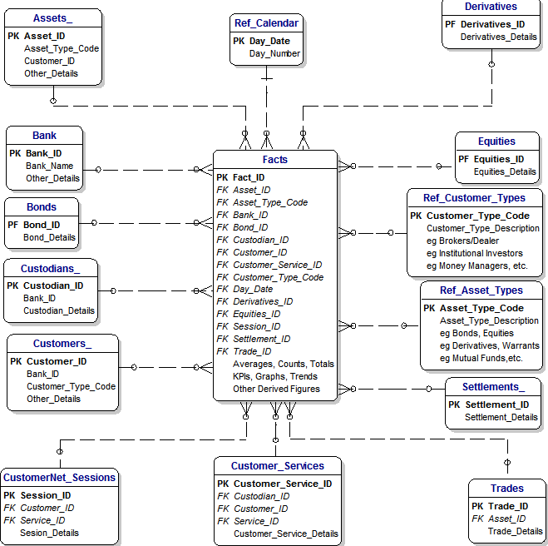

**Screenshot of Some of The Tables**

**Customers Table:**

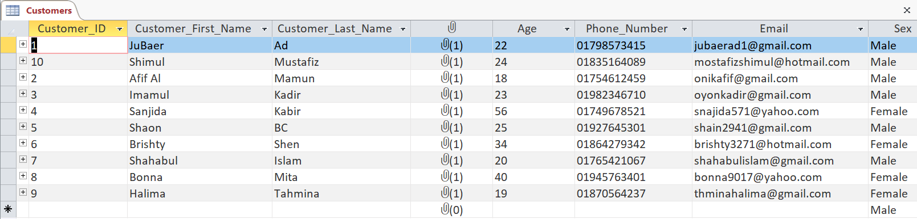

**Bank Table:**

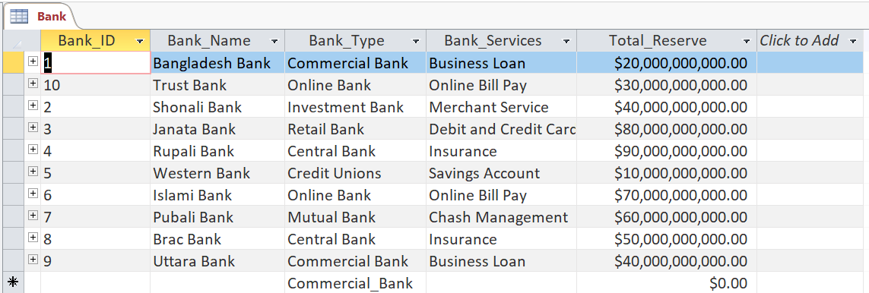

**Bonds Table:**

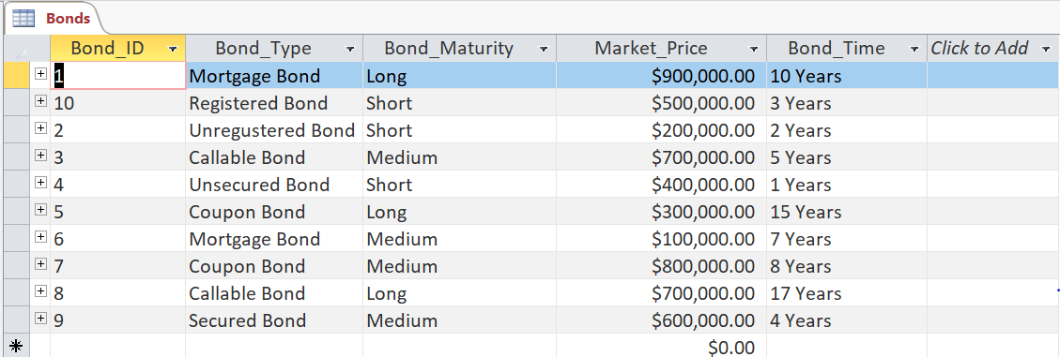

**Settlements Table:**

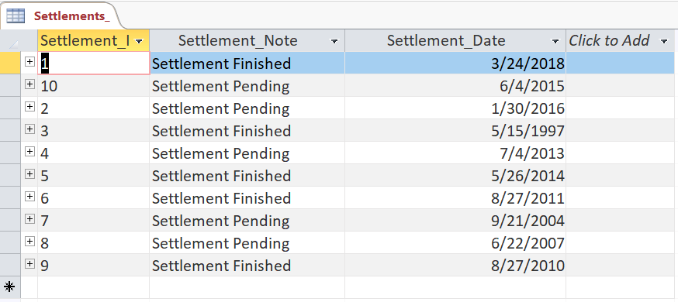

**Customer Services Table:**

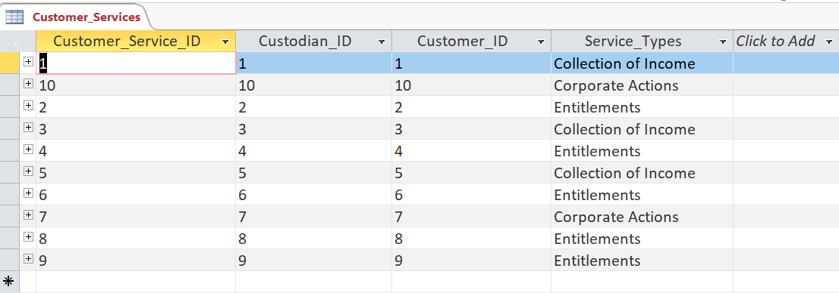

**Switchboard Items Table:**

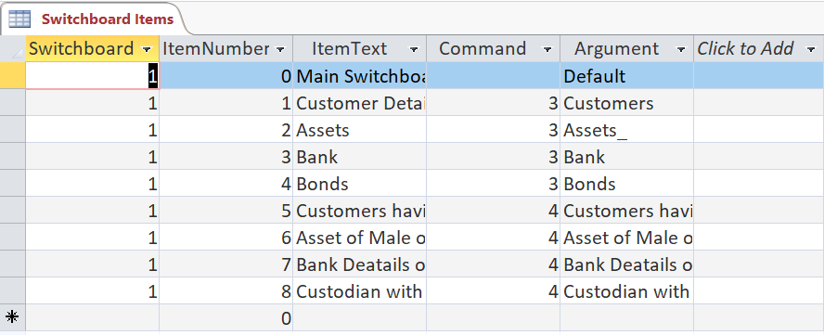

**Reference Asset Types Table:**

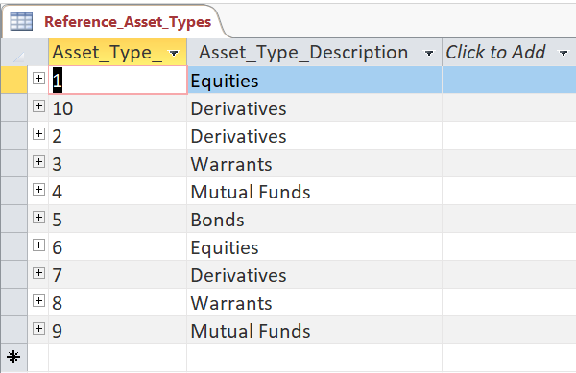

**Custodians Table:**

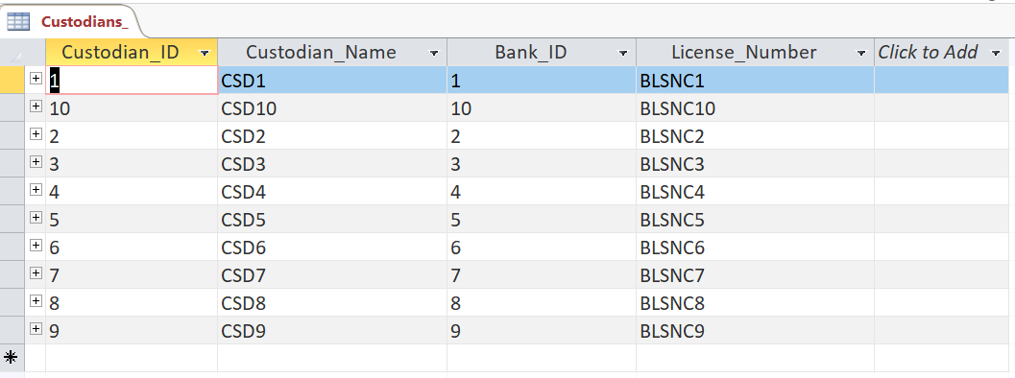

**Trades Table:**

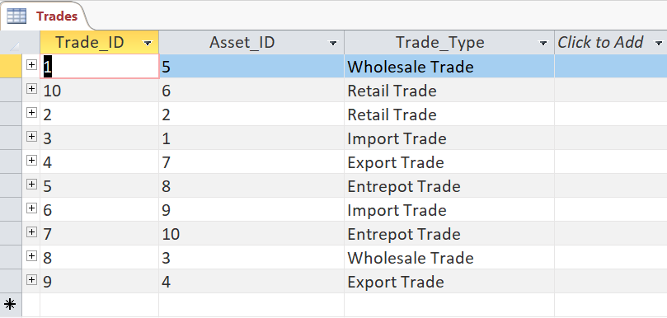

**Derivatives Table:**

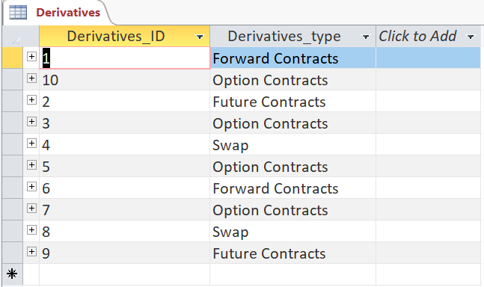

**Screenshots of Forms**

**Form of Switchboard:**

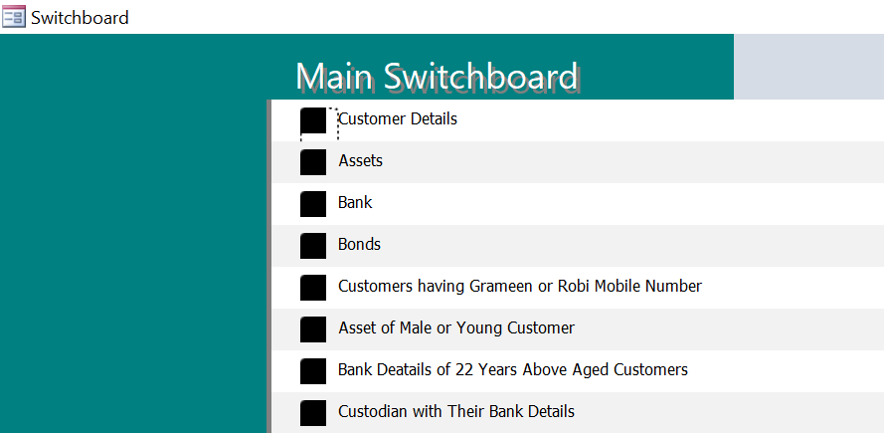

**Admin Login Form:**

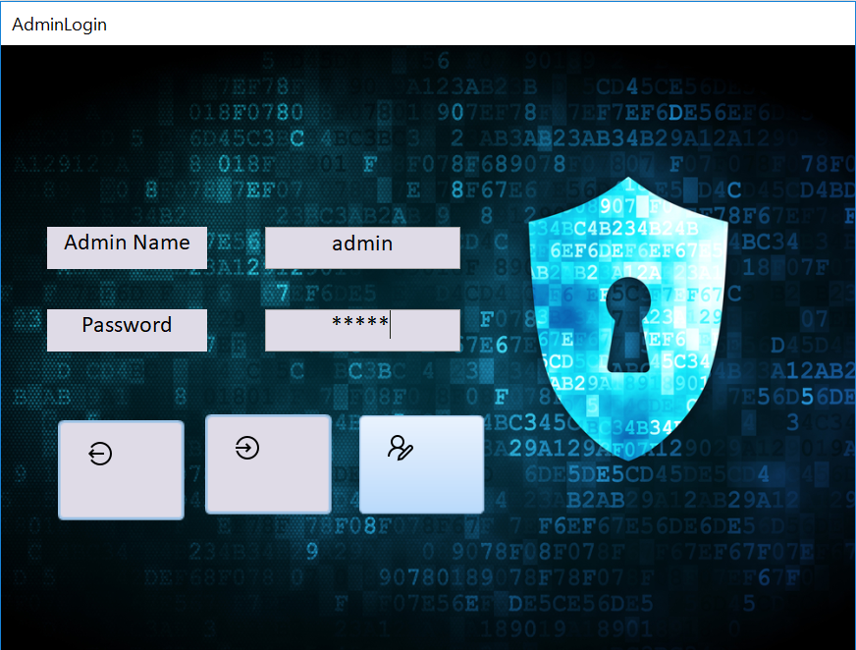

**User Login Form:**

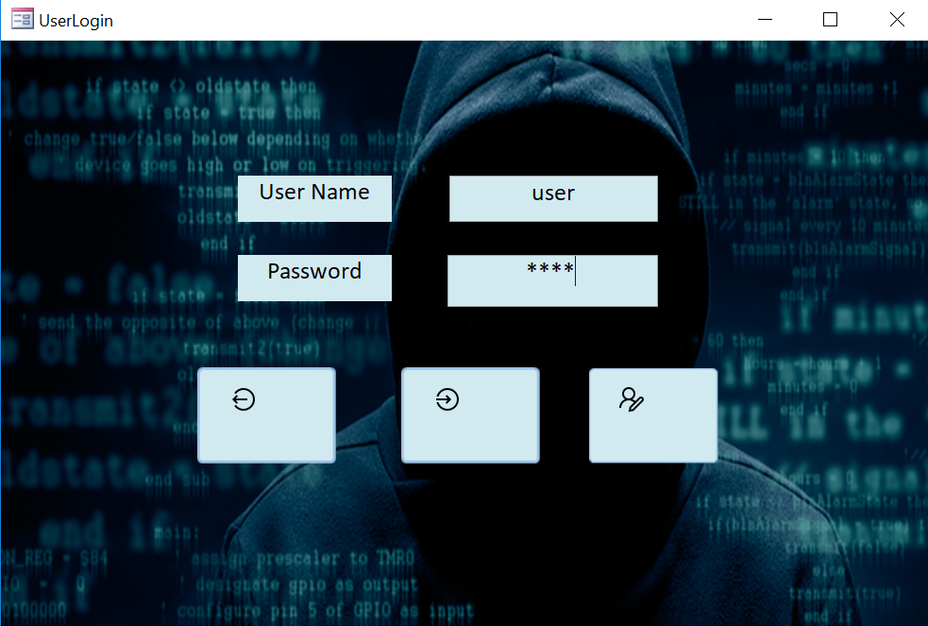

**Admin Login Registration Form:**

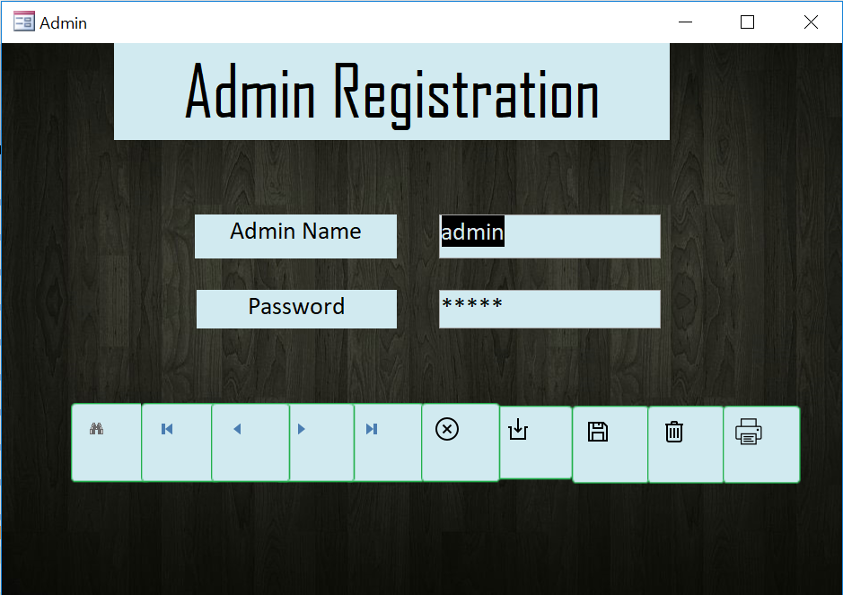

**User Login Registration Form:**

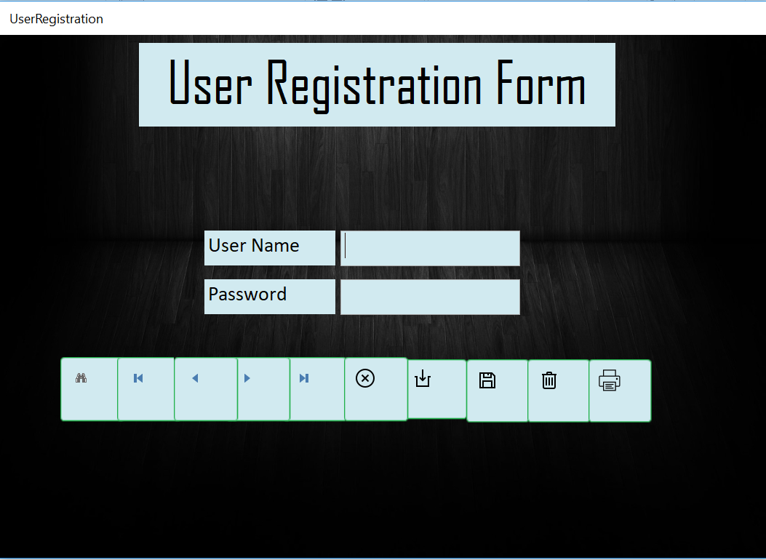

**Customers Form:**

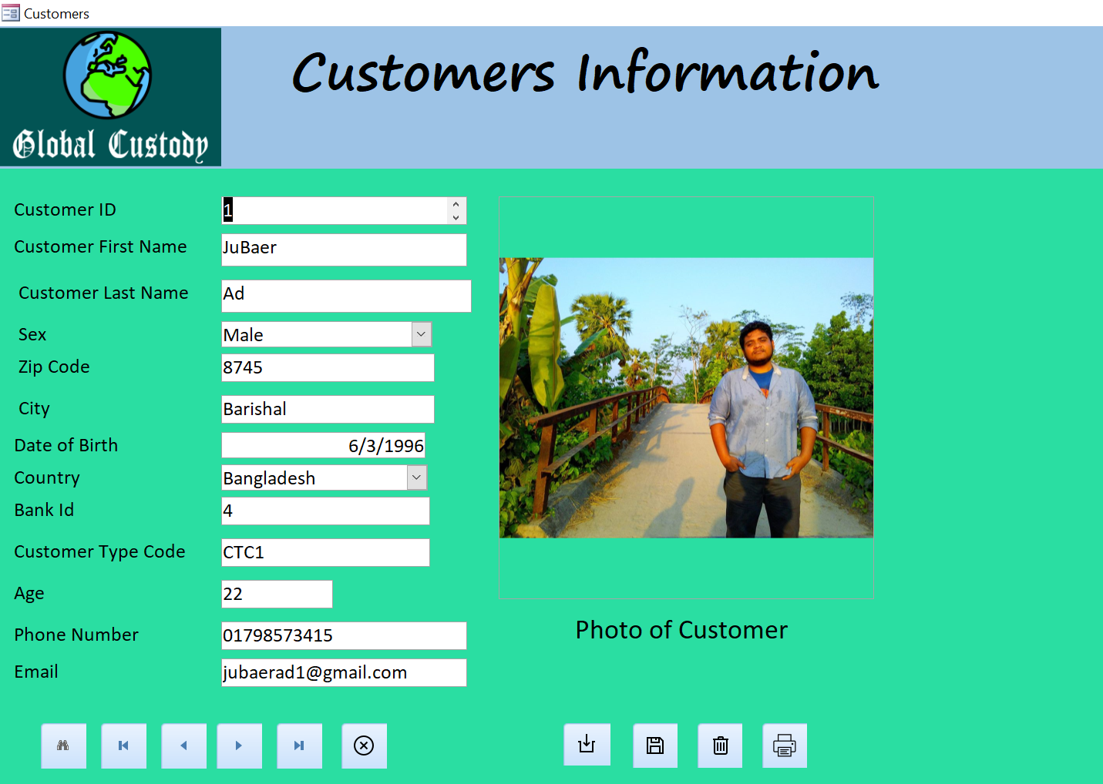

**Assets Form:**

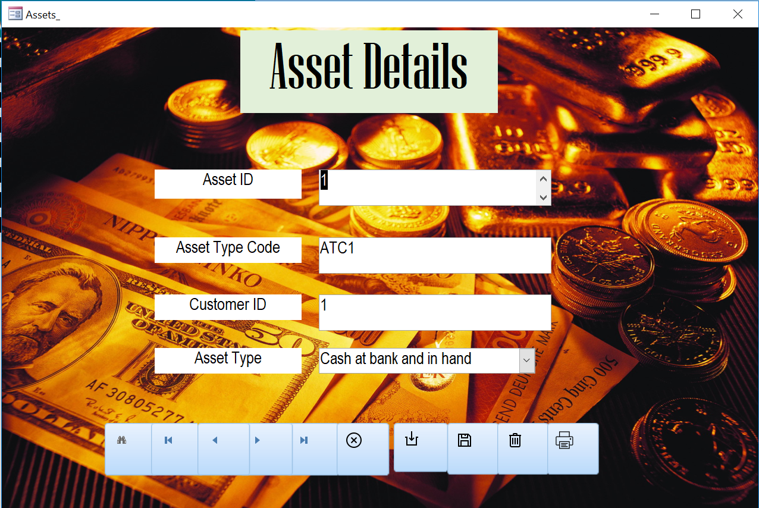

**Bank Form:**

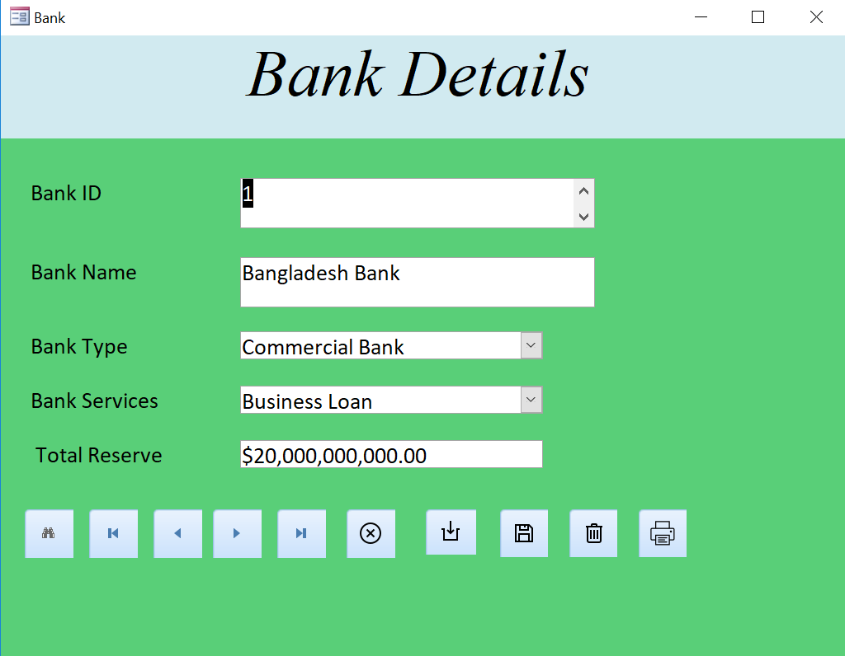

**Bonds Form:**

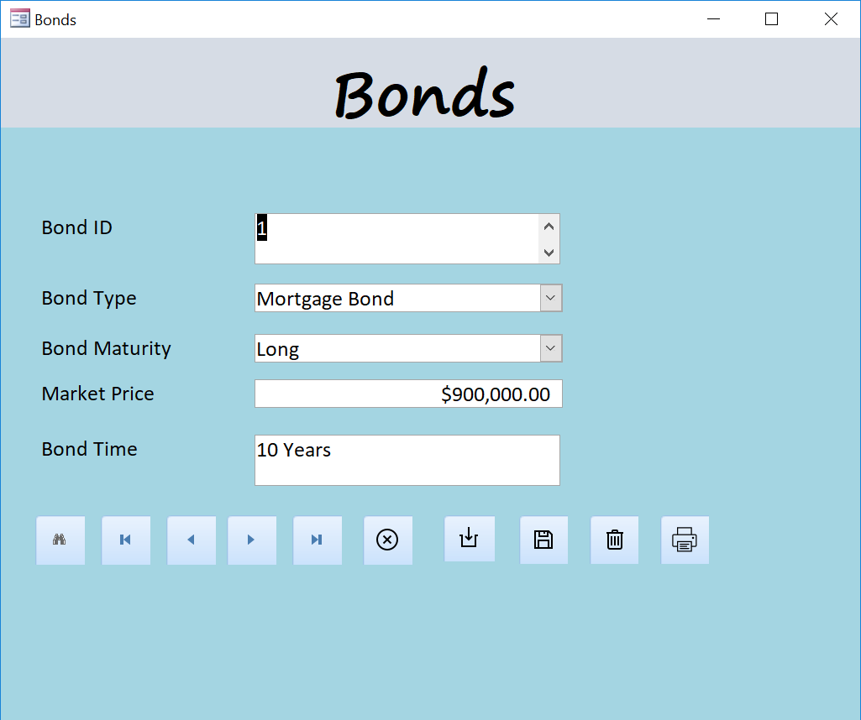

**Reference Calendar Form:**

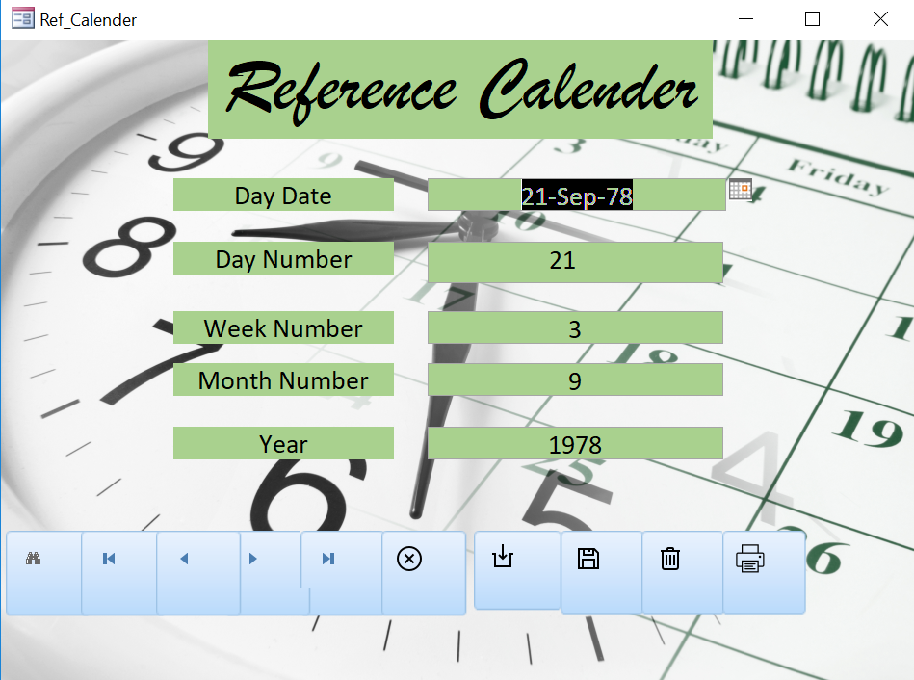

**Screenshots of Some of the Queries**

**Query Design Sample-1:**

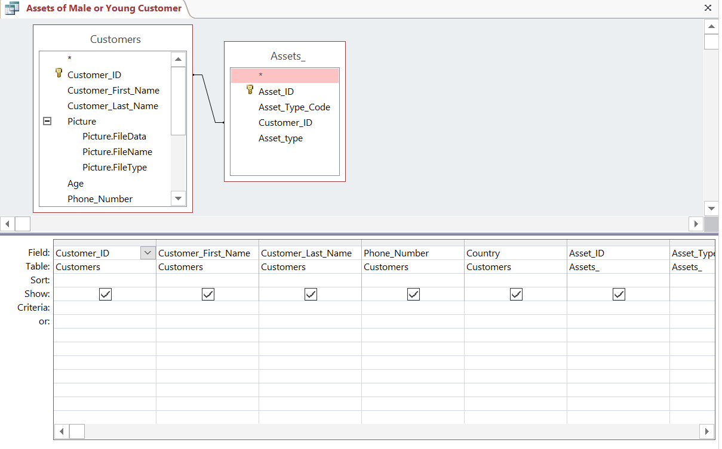

**Query Design Sample-2:**

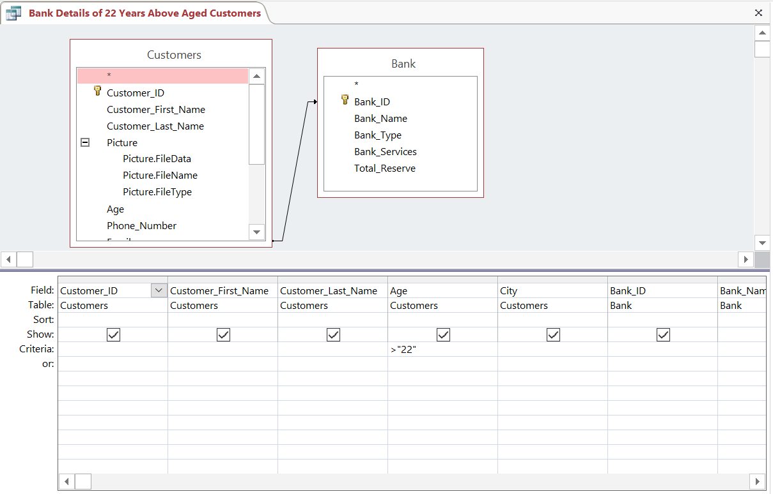

**Query Design View Sample-3:**

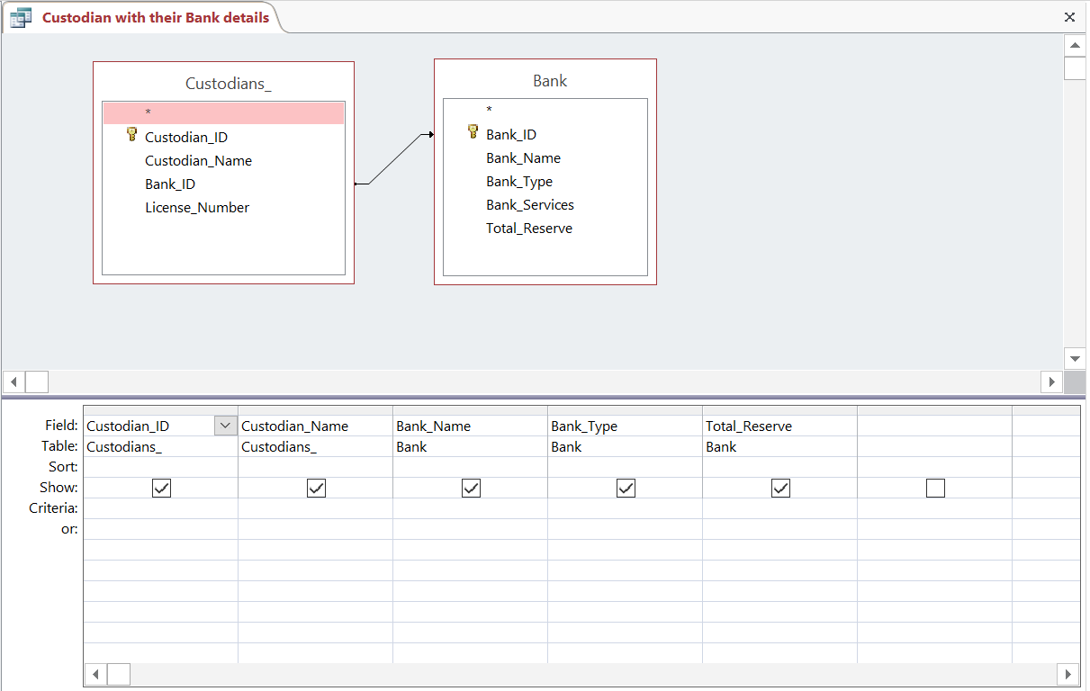

**Screenshots of Reports**

**Report about Asset of Different Types of Customer:**

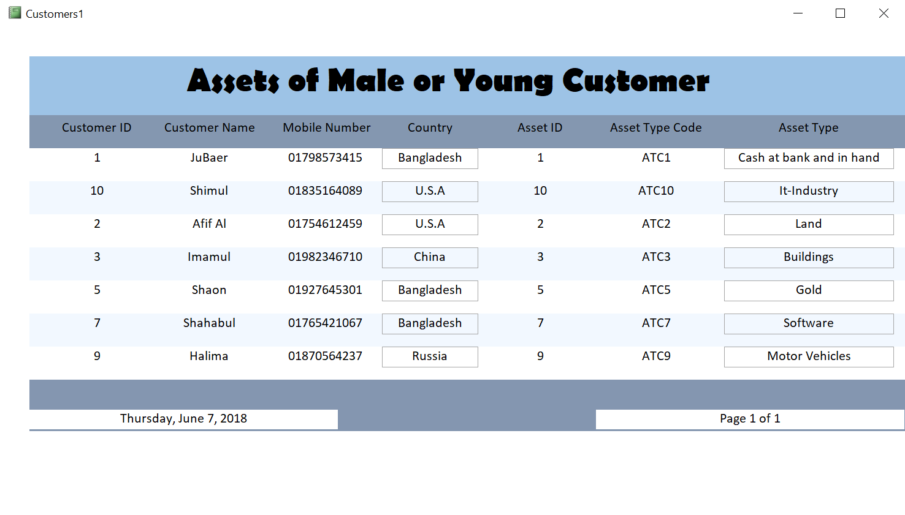

**Report about Particular Aged Customers Bank Details:**

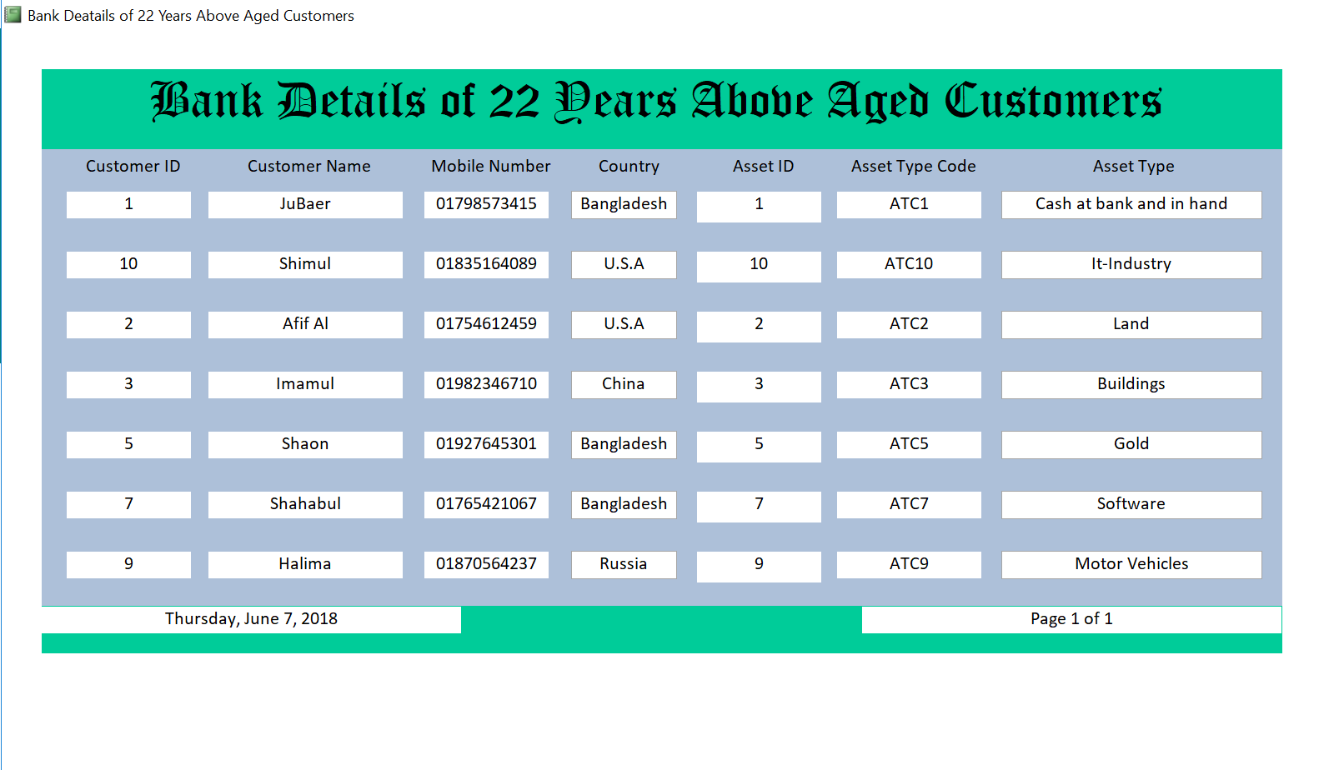

**Report of Different Mobile Operator Users:**

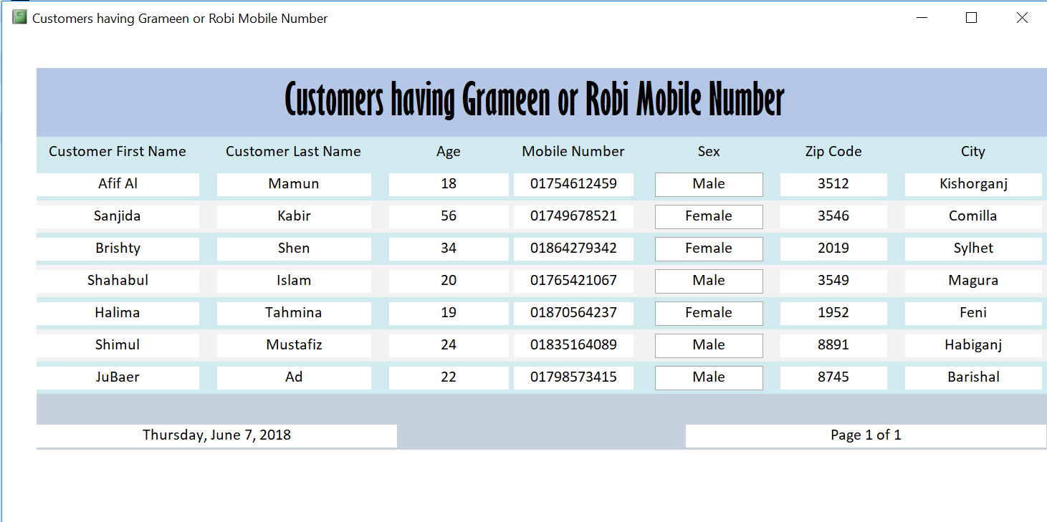

**Report about Different Bank Type:**

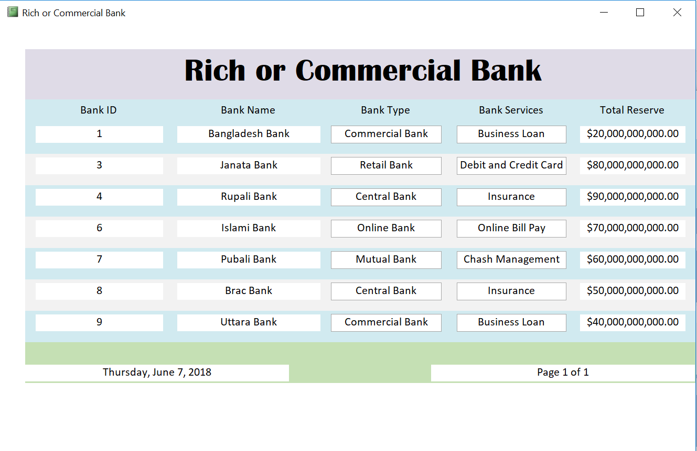

**END**